MOVIE RECOMMENDATION SYSTEM



A mini project report submitted in partial fulfillment of
requirements for the award of

HONORS
IN
COMPUTER SCIENCE & ENGINEERING

By

N. LAKSHMI PRIYA (229X1A05E9)
M. K. HARSHITA (229X1A05E7)

Under the esteemed guidance of
Dr. K. Ishthaq Ahamed
Associate Professor
Department of C. S. E

Department of Computer Science and Engineering
G. PULLA REDDY ENGINEERING COLLEGE (Autonomous): KURNOOL
(Affiliated to JNTUA, ANANTAPURAMU)

2025 - 2026

Department of Computer Science and Engineering
G. PULLA REDDY ENGINEERING COLLEGE (Autonomous): KURNOOL
(Affiliated to JNTUA, ANANTAPURAMU)



CERTIFICATE

This is to certify that the mini project report entitled ‘MOVIE RECOMMENDATION SYSTEM’ is a bonafide record of work carried out by

N. LAKSHMI PRIYA (229X1A05E9)
M. K. HARSHITA (229X1A05E7)

Under my guidance and supervision in partial fulfillment of the requirements for the award of

HONORS
IN
COMPUTER SCIENCE & ENGINEERING

Dr. K. Ishthaq Ahamed Dr. N. Kasiviswanath
Associate Professor, Professor and HOD,
Department of C.S.E, Department of C.S.E,
GPREC, Kurnool. GPREC, Kurnool.

DECLARATION

I hereby declare that the project titled “ MOVIE RECOMMENDATION SYSTEM ” is an authentic work carried out by me as the student of G. PULLA REDDY ENGINEERING COLLEGE(Autonomous) Kurnool, during 2025-26 and has not been submitted elsewhere for the award of any degree or diploma in part or in full to any institute.

N. Lakshmi Priya
(229X1A05E9)

M. K. Harshita
(229X1A05E7)

Acknowledgement

We wish to express our deep sense of gratitude to our project guide Dr. K. ISHTHAQ AHAMED, Associate Professor of Computer Science and Engineering Department, G. Pulla Reddy Engineering College, for his immaculate guidance, constant encouragement and cooperation which have made possible to bring out this project work.
We are grateful to our project incharge Dr. K. ISHTHAQ AHAMED, Associate Professor of Computer Science and Engineering Department, G. Pulla Reddy Engineering College, for helping us and giving us the required information needed for our project work.
We are thankful to our Head of the Department Dr. N. Kasiviswanath, for his whole hearted support and encouragement during the project sessions.
We are grateful to our respected Principal Dr. B. Sreenivasa Reddy for providing requisite facilities and helping us in providing such a good environment.
We wish to convey our acknowledgements to all the staff members of the Computer Science and Engineering Department for giving the required information needed for our project work.
Finally we wish to thank all our friends and well wishers who have helped us directly or indirectly during the course of this project work.

ABSTRACT

In the era of digital entertainment, users are often overwhelmed by the sheer volume of available movies and content. Traditional keyword-based search methods fail to capture user preferences effectively, leading to poor content discovery experiences. This project presents the design and implementation of a content-based Movie Recommendation System that intelligently suggests movies similar to a user-selected title by analyzing movie metadata and plot descriptions.
The core of the system is built on Natural Language Processing (NLP) techniques. Movie metadata including genres, cast, director, and plot overviews are preprocessed and combined into a unified textual representation called 'tags'. These tags are then transformed into numerical vectors using the TF-IDF (Term Frequency-Inverse Document Frequency) vectorization technique, which assigns higher importance to rare and meaningful words while filtering out common, uninformative words. Cosine similarity is subsequently applied to measure the angular distance between movie vectors, enabling the identification of movies that share similar thematic and descriptive characteristics.
The trained model is serialized using Python's pickle module and stored as pre-computed files, ensuring instant recommendation retrieval without reprocessing at runtime. The backend of the application is developed using FastAPI, a high-performance Python web framework, which exposes RESTful API endpoints for home feeds, keyword search, movie details, TF-IDF recommendations, and genre-based recommendations. The frontend is built using Streamlit, which provides an interactive and visually engaging web interface where users can search for movies, browse poster grids, and view detailed recommendations.
Additionally, the system integrates with The Movie Database (TMDB) API to fetch live movie posters, overviews, genres, and metadata, enriching the user experience with up-to-date visual content. The recommendation engine combines two complementary strategies — content-based TF-IDF similarity for plot-driven matches and genre-based TMDB discovery for broader category suggestions — delivering a dual-mode recommendation experience.
The system is deployed on cloud platforms, with the FastAPI backend hosted on Render and the Streamlit frontend accessible via Streamlit Cloud, making it fully accessible as a web application. This project demonstrates the practical application of machine learning, NLP, and full-stack web development in building an end-to-end intelligent recommendation system.

TABLE OF CONTENTS

S. No CHAPTER Page No.
1 INTRODUCTION 3
  - Introduction
  - Motivation
  - Problem Definition
  - Objective of the Project
  - Limitations of the Project
2 | SYSTEM SPECIFICATIONS 6  2.1 Software Specifications  2.2 Hardware Specifications
3 | LITERATURE SURVEY 8  3.1 Introduction  3.2 Existing System  3.3 Disadvantages of Existing System  3.4 Proposed System
4 | DESIGN AND IMPLEMENTATION 11  4.1 Introduction  4.2 System Architecture  4.3 Tools and Technologies Used  4.4 Implementation Details  4.5 Results and Output
5 | CONCLUSION 20

6 REFERENCES 21

1. INTRODUCTION

1.1 Introduction

Recommendation systems have become an indispensable part of modern digital platforms, helping users navigate vast amounts of content by providing personalized suggestions. In the context of the entertainment industry, movie recommendation systems play a vital role in enhancing user engagement, reducing content discovery time, and improving overall viewing satisfaction. With streaming platforms hosting hundreds of thousands of titles, the need for intelligent, automated recommendation engines has never been greater.

This project presents a full-stack Movie Recommendation System that leverages content-based filtering powered by Natural Language Processing (NLP) techniques. The system analyses movie descriptions, genres, cast, and director information to build a mathematical model that identifies similarities between movies. When a user searches for a movie they enjoyed, the system instantly returns a list of movies with similar thematic and descriptive characteristics.

The application is built as a two-tier web system: a FastAPI backend that handles all data processing, machine learning inference, and external API communication, and a Streamlit frontend that provides users with an interactive, poster-rich browsing experience. The system also integrates with The Movie Database (TMDB) API to retrieve real-time movie posters, details, and genre-based recommendations.

1.2 Motivation

The motivation behind this project stems from the everyday challenge of choosing what to watch next. Despite having access to thousands of movies, users frequently experience 'decision fatigue' — spending more time searching than actually watching. Existing recommendation approaches either rely solely on user ratings (collaborative filtering), which requires large amounts of user data, or provide generic genre-based lists that lack personalization.

Content-based filtering addresses this gap by analyzing the content of movies themselves — their plot, genre, cast, and direction — rather than relying on the behavior of other users. This makes it particularly effective for new users or for movies with few ratings. Furthermore, by building the system as a deployable web application with a live external API integration, the project bridges the gap between academic machine learning models and real-world production systems.

1.3 Problem Statement

The core problem addressed by this project is: given a movie that a user likes, how can the system automatically identify and present other movies that are likely to appeal to the same user, based purely on the content and characteristics of the movies themselves?

Formally, the system must:
- Accept a movie title as input from the user.
- Retrieve the movie's metadata — plot overview, genres, cast, and director.
- Compute similarity scores between the input movie and all other movies in the dataset.
- Return the top N most similar movies along with their posters and details.
- Handle edge cases such as movies not present in the local dataset by falling back to genre-based recommendations from TMDB.

Objective of the Project

The primary objectives of this project are as follows:
- To build a content-based movie recommendation engine using TF-IDF vectorization and cosine similarity.
- To develop a FastAPI backend that exposes clean, versioned RESTful API endpoints for all recommendation and search operations.
- To create a Streamlit-based frontend that presents movie posters, search results, and recommendations in a visually appealing, responsive layout.
- To integrate the TMDB API for real-time movie poster retrieval, metadata enrichment, and genre-based content discovery.

- To serialize and persist the trained machine learning model using pickle files for instant, stateless inference at runtime.
- To deploy the application on cloud platforms, making it accessible as a fully functional web application.
- To demonstrate an end-to-end machine learning pipeline from data preprocessing and model training to deployment and user interaction.

Limitations of the Project

While the system is functional and effective, the following limitations are acknowledged:
- The recommendation model is static — it is trained on a fixed dataset and does not update automatically when new movies are released. Periodic retraining is required to keep the dataset current.
- The system uses content-based filtering only. It does not incorporate collaborative filtering or hybrid methods, which could improve recommendation quality by factoring in user preferences and ratings.
- The quality of recommendations depends heavily on the richness and accuracy of the movie metadata (tags). Movies with sparse or poorly written descriptions may receive less accurate recommendations.
- The system does not maintain user profiles or browsing history, meaning recommendations are stateless and cannot be personalized across sessions.
- The TMDB API has rate limits. Under heavy traffic, poster retrieval may experience delays or temporary failures.
- The TF-IDF model operates on English text only. Non-English movies with descriptions in other languages may not be compared accurately.

2. SYSTEM SPECIFICATIONS

2.1 Software Specifications

Operating System: The project was developed and tested on Windows 10 / Ubuntu 20.04. Both platforms fully support Python 3.11 and all required libraries.
Programming Language: Python 3.11.9 serves as the sole programming language across all components — data preprocessing, model training, backend API, and frontend interface.
Frontend Framework: Streamlit 1.36.0 is used to build the web interface. It converts Python scripts into interactive web applications without requiring HTML, CSS, or JavaScript.
Backend Framework: FastAPI 0.111.0 powers the REST API server. It handles all incoming requests, processes recommendations, and communicates with the TMDB API.
ASGI Server: Uvicorn 0.30.1 runs the FastAPI application. It is a lightweight, high-performance server that keeps the backend alive and handles concurrent requests.
Machine Learning Library: scikit-learn 1.5.1 provides the TfidfVectorizer used to convert movie descriptions into numerical vectors and the cosine similarity function used during model training.
Data Processing: pandas 2.2.2 manages the movie dataset as a structured table and handles row lookups. numpy 2.0.1 performs array operations and sorts similarity scores efficiently.
Sparse Matrix Operations: scipy 1.13.1 stores the TF-IDF matrix in compressed sparse format, significantly reducing memory usage since most word-movie value pairs are zero.
HTTP Client: httpx 0.27.0 performs asynchronous HTTP calls from the FastAPI backend to the TMDB API. The requests library is used in the Streamlit frontend to call the backend.
Data Serialization: Python's built-in pickle module saves and loads the trained model objects — the TF-IDF matrix, vectorizer, movie DataFrame, and index map — to and from disk.
Environment Management: python-dotenv 1.0.1 loads the TMDB API key from a hidden .env file, keeping the secret key out of the source code.
External API: The TMDB (The Movie Database) API v3 provides live movie posters, overviews, genres, cast details, and genre-based movie discovery for every search and recommendation request.
Deployment: The FastAPI backend is deployed on Render and the Streamlit frontend is hosted on Streamlit Cloud, making the application accessible as a live web application.

2.2 Hardware Specifications

Processor: Intel Core i3 or equivalent minimum. An i5 or i7 is recommended for faster model training during the notebook phase.
RAM: A minimum of 4 GB is required. 8 GB is recommended, particularly when loading the TF-IDF sparse matrix into memory at server startup.
Storage: At least 10 GB of free disk space is needed to accommodate Python packages, the movie dataset, pickle files, and project files.
Internet Connection: A stable internet connection is required for all TMDB API calls, which fetch live movie posters and metadata on every user request.
Display: A minimum resolution of 1280×720 is recommended for comfortable use of the Streamlit interface, which uses a wide layout with a multi-column poster grid.

3. LITERATURE SURVEY

3.1 Introduction

Recommendation systems are one of the most widely studied areas in machine learning and information retrieval. They have been applied extensively in e-commerce (Amazon), streaming services (Netflix, Spotify), and social media platforms (YouTube, Facebook). The fundamental goal of a recommendation system is to predict what items a user is likely to be interested in, based on various signals such as past behavior, item content, and community preferences.

Research in recommendation systems has evolved over three primary paradigms: collaborative filtering, content-based filtering, and hybrid approaches. Each paradigm has distinct strengths, weaknesses, and applicability depending on the use case and available data.

3.2 Existing System

Collaborative Filtering (CF) is one of the earliest and most widely adopted recommendation approaches. It identifies users with similar preferences and recommends items that those similar users have liked. Netflix, Amazon, and YouTube have historically relied heavily on collaborative filtering. Matrix factorization techniques such as Singular Value Decomposition (SVD) and Alternating Least Squares (ALS) improved CF's scalability significantly.

Content-Based Filtering (CBF) recommends items similar to those a user has interacted with, based on the intrinsic properties of items — such as movie genres, director, cast, and plot descriptions. Early CBF systems used simple keyword matching and bag-of-words models. Modern systems employ TF-IDF vectorization, Word2Vec embeddings, and BERT-based transformers for richer semantic representations.

Hybrid Systems combine collaborative and content-based approaches to overcome the limitations of each. Netflix's current recommendation system is an example of a sophisticated hybrid that blends matrix factorization, neural networks, and content signals.

Deep Learning-based recommendation systems have gained significant traction in recent years. Models like Neural Collaborative Filtering (NCF) and Wide & Deep networks leverage neural architectures to learn complex, non-linear user-item interactions. However, these models require large-scale labeled data and significant computational resources.

3.3 Disadvantages of Existing System

- Collaborative filtering suffers from the cold-start problem — it cannot make accurate recommendations for new users or new movies with no interaction history.
- Traditional content-based systems using bag-of-words models fail to capture semantic meaning. Two movies with different words but the same theme may not be correctly identified as similar.
- Collaborative filtering requires large amounts of user interaction data, making it impractical for small-scale or niche platforms.
- Deep learning-based systems, while powerful, are computationally expensive to train and require specialized infrastructure for deployment.
- Most existing systems lack a user-friendly, visually rich interface that makes recommendations accessible to general audiences.
- Existing academic implementations are often not deployed as production-ready applications, creating a gap between research prototypes and real-world usability.

3.4 Proposed System

The proposed Movie Recommendation System addresses the above limitations by adopting a content-based filtering approach that is practical, lightweight, and fully deployable. The system uses TF-IDF vectorization to convert movie metadata into numerical vectors and cosine similarity to measure movie-to-movie similarity. This approach avoids the cold-start problem entirely, since no user interaction history is required.

Key advantages of the proposed system include:
- No dependency on user history or ratings — works immediately for any movie in the dataset.
- Pre-computed model stored as pickle files ensures millisecond-level recommendation inference at runtime.
- Dual recommendation strategy — TF-IDF content similarity for plot-driven matches combined with TMDB genre discovery for broader suggestions.
- Full-stack deployment as a production web application with a polished Streamlit UI and a FastAPI REST backend.
- Live integration with the TMDB API for up-to-date posters, metadata, and genre-based content.
- Graceful error handling and fallback mechanisms ensure the system remains functional even when specific movies are not found in the local dataset.

4. DESIGN AND IMMMPLEMENTATION

4.1 Introduction

This chapter describes the detailed design and implementation of the Movie Recommendation System. The system is structured as a two-tier web application with a machine learning core. The first tier is a FastAPI backend responsible for loading pre-trained models, computing recommendations, and communicating with the TMDB API. The second tier is a Streamlit frontend that renders the user interface. The two tiers communicate via HTTP REST API calls.

The overall development process followed a three-phase pipeline: (1) offline training in a Jupyter Notebook, (2) backend API development with FastAPI, and (3) frontend UI development with Streamlit.

4.2 System Architecture
The system architecture follows a client-server model with an external API integration:
- User (Browser): The end user interacts with the Streamlit web interface.
- Streamlit Frontend (app.py): Handles all UI rendering, user input, session state management, and HTTP communication with the backend.
- FastAPI Backend (main.py): Receives HTTP requests, processes them using the ML model and TMDB API, and returns structured JSON responses.
- TF-IDF Engine (local): The recommendation core — loads pickle files at startup and performs cosine similarity computation for content-based recommendations.
- TMDB API (external): Provides live movie posters, metadata, search results, and genre-based movie discovery.

At startup, the FastAPI server loads four pickle files into memory: df.pkl (the movie DataFrame), tfidf_matrix.pkl (the precomputed TF-IDF sparse matrix), indices.pkl (the title-to-row-index mapping), and tfidf.pkl (the trained TF-IDF vectorizer). These remain in memory for the lifetime of the server, enabling instant recommendations without disk I/O on each request.

4.3. Tools and Technologies Used
- Python 3.11: Primary programming language for all components.
- scikit-learn (TfidfVectorizer): Converts movie tag descriptions into TF-IDF feature vectors. Configured with max_features=50,000, ngram_range=(1,2) to capture both unigrams and bigrams, and stop_words='english' to remove uninformative words.
- scipy (Sparse Matrix): Stores the TF-IDF matrix in compressed sparse row (CSR) format, drastically reducing memory usage since most word-movie combinations are zero.
- numpy (argsort): Used for efficient sorting of cosine similarity scores to identify the top-N most similar movies.
- pandas (DataFrame): Stores the movie dataset as a structured table and enables fast row lookups by index.
- pickle: Serializes and deserializes the trained model objects to and from disk.
- FastAPI: Builds the RESTful backend API with automatic request validation, asynchronous request handling, and auto-generated API documentation.
- Pydantic: Defines data models for request and response validation, ensuring type safety across all API endpoints.
- httpx: Performs asynchronous HTTP calls from the FastAPI backend to the TMDB API.
- Streamlit: Builds the interactive frontend web interface without requiring HTML, CSS, or JavaScript.
- TMDB API: External REST API providing movie search, details, posters, and genre-based discovery.

4.4. Implementation Details

Phase 1 — Model Training (movies.ipynb):
The training phase begins with loading the movies dataset into a pandas DataFrame. Each movie's metadata — title, overview, genres, cast, and director — is preprocessed and combined into a single textual field called tags. The TfidfVectorizer from scikit-learn is then applied to the tags column, transforming the entire dataset into a sparse TF-IDF matrix. The recommend() function uses cosine_similarity() to compute pairwise similarity scores between a query movie and all others, sorts the scores in descending order using numpy's argsort(), and returns the top N titles. All trained objects are saved to disk using pickle.dump().

# 1. Building the tags column
tfidf = TfidfVectorizer(max_features=50000, ngram_range=(1,2), stop_words='english')
tfidf_matrix = tfidf.fit_transform(df['tags'])

# 2. The recommend function
def recommend(title, n=10):
idx = indices[title]
sim_score = cosine_similarity(tfidf_matrix[idx], tfidf_matrix).flatten()
similar_idx = sim_score.argsort()[::-1][1:n+1]
return df['title'].iloc[similar_idx]

# 3. Saving the model
pickle.dump(tfidf_matrix, open('tfidf_matrix.pkl','wb'))
pickle.dump(indices, open('indices.pkl','wb'))
df.to_pickle('df.pkl')
pickle.dump(tfidf, open('tfidf.pkl','wb'))

Phase 2 — Backend API (main.py):
The FastAPI application defines a startup event handler (load_pickles) that loads all four pickle files into global memory variables when the server starts. The core recommendation logic is encapsulated in the tfidf_recommend_titles() function, which retrieves the query movie's row from the sparse matrix, performs a matrix multiplication (tfidf_matrix @ qv.T) against all rows to produce cosine similarity scores, sorts the results using numpy, and returns a ranked list of (title, score) pairs.

The principal API endpoint is /movie/search, which serves as a bundle endpoint returning movie details, TF-IDF recommendations with TMDB posters, and genre-based TMDB recommendations in a single response. The endpoint implements a two-level fallback: it first attempts TF-IDF recommendations using the TMDB-resolved title, and if that fails, retries with the original user query. If both fail, genre-based recommendations from TMDB are returned instead, ensuring the user always receives meaningful results.

# 1. Loading pickle files at startup
@app.on_event("startup")
def load_pickles():
global df, indices_obj, tfidf_matrix, tfidf_obj, TITLE_TO_IDX
with open(DF_PATH, "rb") as f:
df = pickle.load(f)
with open(TFIDF_MATRIX_PATH, "rb") as f:
tfidf_matrix = pickle.load(f)
with open(INDICES_PATH, "rb") as f:
indices_obj = pickle.load(f)
TITLE_TO_IDX = build_title_to_idx_map(indices_obj)

# 2. Core TF-IDF recommendation logic
def tfidf_recommend_titles(query_title: str, top_n: int = 10):
idx = get_local_idx_by_title(query_title)
qv = tfidf_matrix[idx]
scores = (tfidf_matrix @ qv.T).toarray().ravel()
order = np.argsort(-scores)
out = []
for i in order:
if int(i) == int(idx):
continue
out.append((str(df.iloc[int(i)]["title"]), float(scores[int(i)])))
if len(out) >= top_n:
break
return out

# 3. The bundle endpoint (main route called by frontend)

@app.get("/movie/search", response_model=SearchBundleResponse)
async def search_bundle(query: str, tfidf_top_n: int = 12, genre_limit: int = 12):
best = await tmdb_search_first(query)
tmdb_id = int(best["id"])
details = await tmdb_movie_details(tmdb_id)

# TF-IDF recs with fallback

try:
recs = tfidf_recommend_titles(details.title, top_n=tfidf_top_n)
except:
recs = []

# Genre recs via TMDB

genre_id = details.genres[0]["id"]
discover = await tmdb_get("/discover/movie", {"with_genres": genre_id, ...})
return SearchBundleResponse(...)

Phase 3 — Frontend UI (app.py):
The Streamlit application implements a single-file multi-page routing system using st.session_state and st.query_params. The application has two views: the Home view (poster grid with search and category filters) and the Details view (movie information with dual recommendation grids). The @st.cache_data decorator with a 30-second TTL is used to cache API responses, reducing redundant backend calls for autocomplete suggestions. The poster_grid() function dynamically renders a configurable grid of movie posters using Streamlit columns.

# 1. Session state routing
if "view" not in st.session_state:
st.session_state.view = "home"

def goto_details(tmdb_id: int):
st.session_state.view = "details"
st.session_state.selected_tmdb_id = int(tmdb_id)
st.query_params["view"] = "details"
st.query_params["id"] = str(int(tmdb_id))
st.rerun()

# 2. Cached API call helper
@st.cache_data(ttl=30)
def api_get_json(path: str, params=None):
r = requests.get(f"{API_BASE}{path}", params=params, timeout=25)
return r.json(), None

# 3. Poster grid renderer
def poster_grid(cards, cols=6, key_prefix="grid"):
rows = (len(cards) + cols - 1) // cols
idx = 0
for r in range(rows):
colset = st.columns(cols)
for c in range(cols):
m = cards[idx]; idx += 1
with colset[c]:
st.image(m.get("poster_url"), use_column_width=True)
if st.button("Open", key=f"{key_prefix}_{r}_{c}_{idx}"):
goto_details(m.get("tmdb_id"))

4.5 Results and Output

The system successfully provides accurate and relevant movie recommendations based on content similarity. When a user searches for a movie such as 'Inception', the system returns a set of TF-IDF recommendations featuring movies with similar themes — such as films involving psychological complexity, non-linear narratives, and heist elements. Simultaneously, genre-based recommendations from TMDB provide additional Sci-Fi and Thriller titles, offering the user a broader selection.

The Streamlit frontend renders a clean, wide-layout interface with a search bar, a sidebar for category and column customization, a poster grid for browsing, and a detailed movie page showing the poster, overview, genres, backdrop image, and two separate recommendation carousels. The application is fully deployed and accessible online.

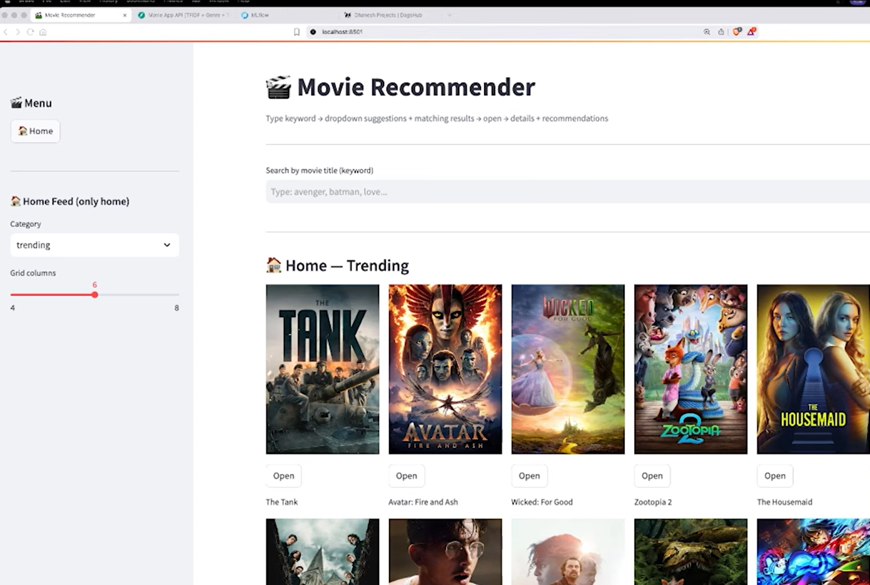

Figure 4.1 Home page of the movie recommender with search bar and trending movies

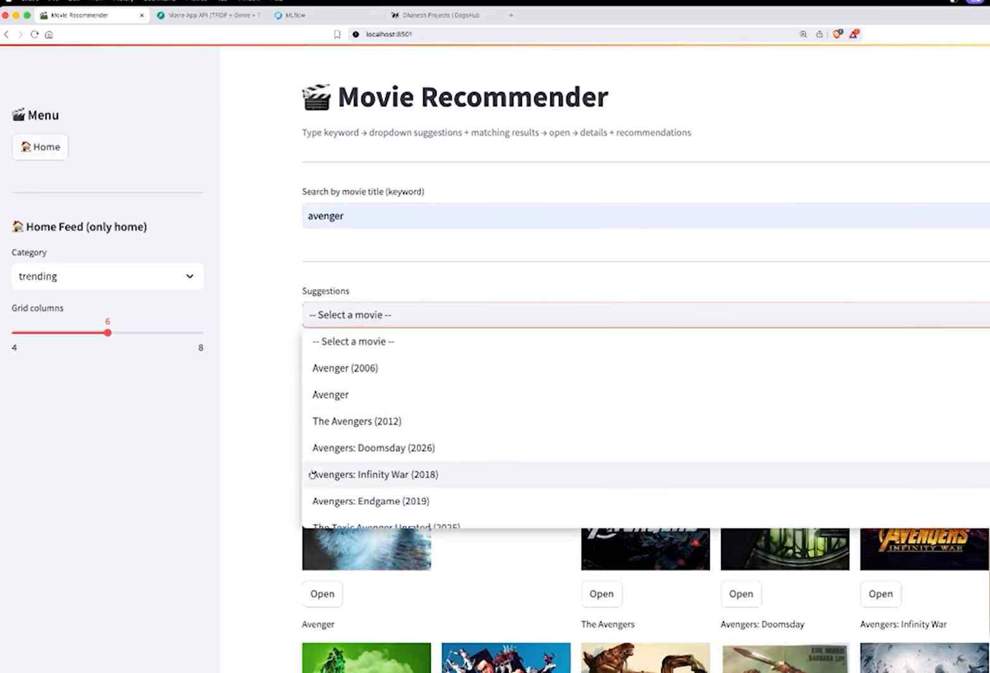
Figure 4.2 Suggestions dropdown shows similar movies to the searched movie
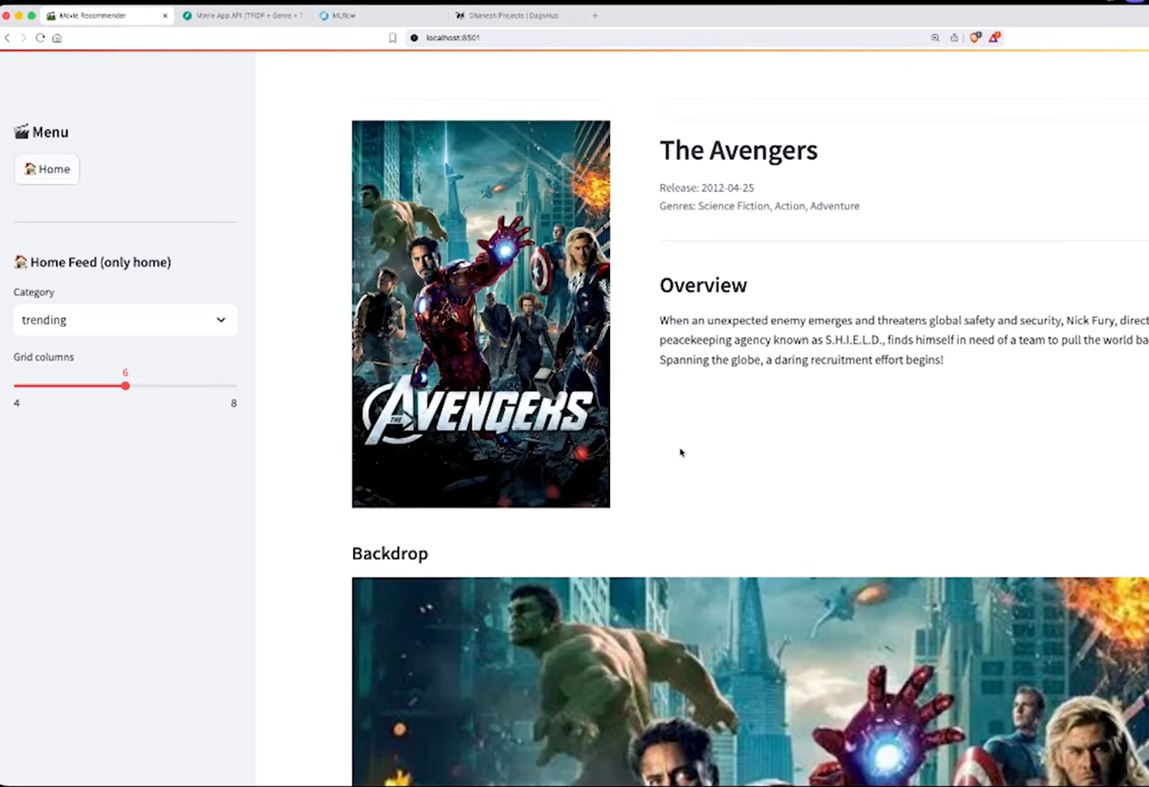
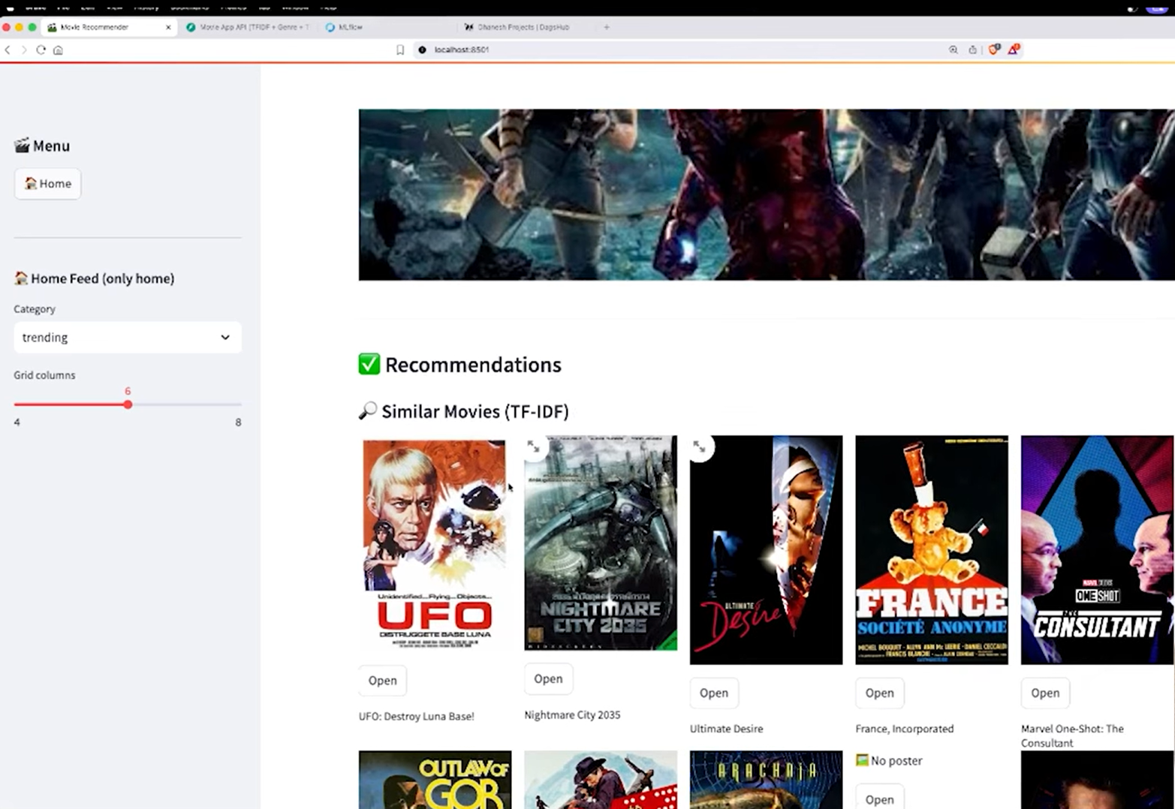

Figure 4.3 Recommendations section shows similar movies to the searched movie

5. CONCLUSION

This project successfully demonstrates the design, development, and deployment of a full-stack, content-based Movie Recommendation System. The core recommendation engine, based on TF-IDF vectorization and cosine similarity, proved effective in identifying thematically and descriptively similar movies from a large dataset. By precomputing the TF-IDF matrix and storing it as a pickle file, the system achieves near-instant recommendation inference at runtime. The dual recommendation strategy — combining content-based TF-IDF similarity with TMDB genre-based discovery — provides users with both precise, plot-driven matches and broader genre-level suggestions, bridging the gap between academic machine learning models and production-grade web applications.

Through this project, the team gained comprehensive, hands-on experience in the full machine learning development lifecycle — from data preprocessing and model training to API development, UI design, and cloud deployment. The FastAPI backend demonstrated the value of asynchronous Python frameworks for building scalable, well-structured APIs, while the Streamlit frontend showed how Python alone can produce a visually engaging web application. The TMDB API integration further enriched the user experience by providing live posters and metadata that a static dataset alone cannot offer.

Future enhancements could include incorporating collaborative filtering or a hybrid recommendation approach to personalize suggestions based on individual user history. Integrating user authentication and a session-based preference system would enable persistent, cross-visit recommendations. Additionally, automating the model retraining pipeline to regularly incorporate newly released movies would ensure the recommendation engine remains current without manual intervention.

6. REFERENCES

- FastAPI Documentation — https://fastapi.tiangolo.com
- Streamlit Documentation — https://docs.streamlit.io
- scikit-learn Documentation — https://scikit-learn.org/stable/modules/generated/sklearn.feature_extraction.text.TfidfVectorizer.html
- The Movie Database (TMDB) API Documentation — https://developer.themoviedb.org/docs
- TMDB Movies Dataset — https://www.kaggle.com/datasets/tmdb/tmdb-movie-metadata
- NumPy Documentation — https://numpy.org/doc/stable/

